**Project tracking:**

Choose “project tracking” in main menu. This shows two options.

**a.** Gantt charts.

**b.** Communication tracking.

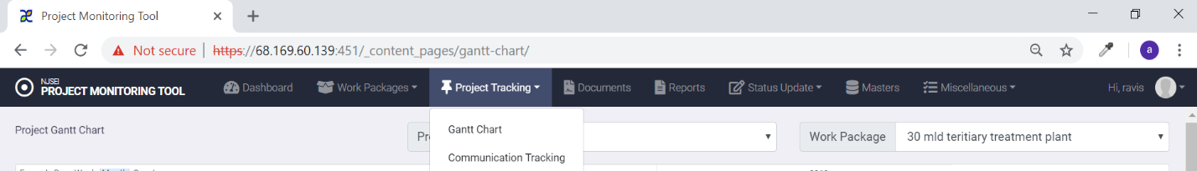

* 1. **Gantt chart:**

1. Click on “Project tracking “in main menu.
2. Choose “Gantt charts” in drop down.

You see following screen.

Gantt chart shows project status, delays, dependencies.

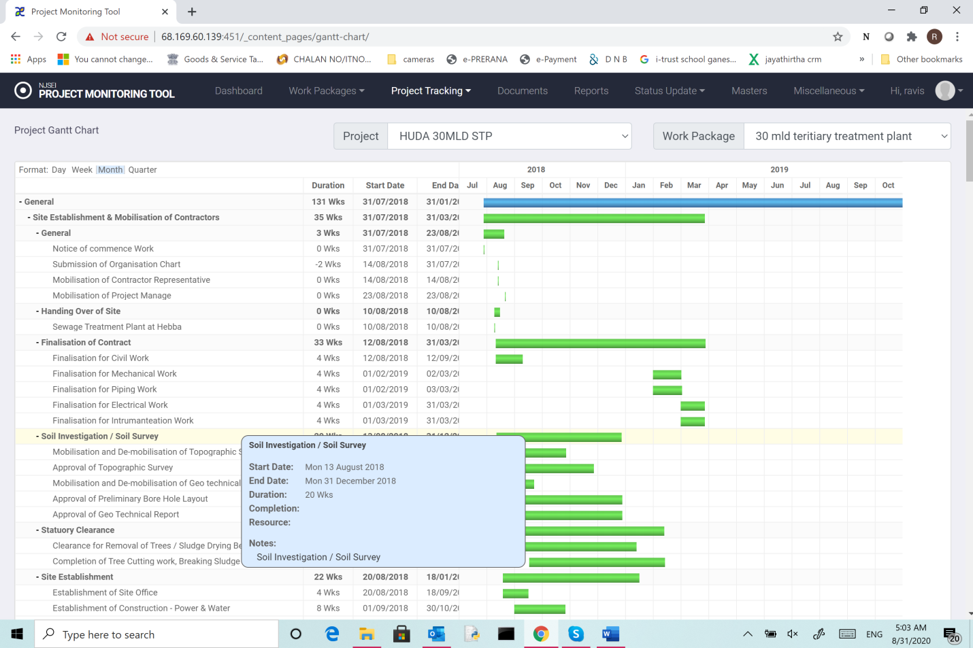

As you can see in the figure below, Gantt chart supports option to view project progress

1. Day,
2. Week,
3. Month and
4. Quarter

The following information is shown in Gantt chart.

1. Activity tree – This shows all tasks, sub-tasks, in a tree view. The “+” sign at the beginning of the node in the tree can be used to collapse/expand any sub-tasks under a task. The node names of the ree represent the names of tasks/sub-tasks etc..
2. Duration: This for any tree element shows the duration in the period selected for the task.
3. Start date: Shows the start date of the task.
4. End Date : Shows end date of the task.
5. The colored bar shows the status of the activity.

Blue: Delayed.

Green : In progress,

Red: Delayed.

The mouse-over of any bar shows the details of the task as shown in the screen shot.

* 1. **Communication Tracking:**

This is to track communication between different entities.



In the main menu click Project tracking and choose “Communication tracking”

You will see following screen

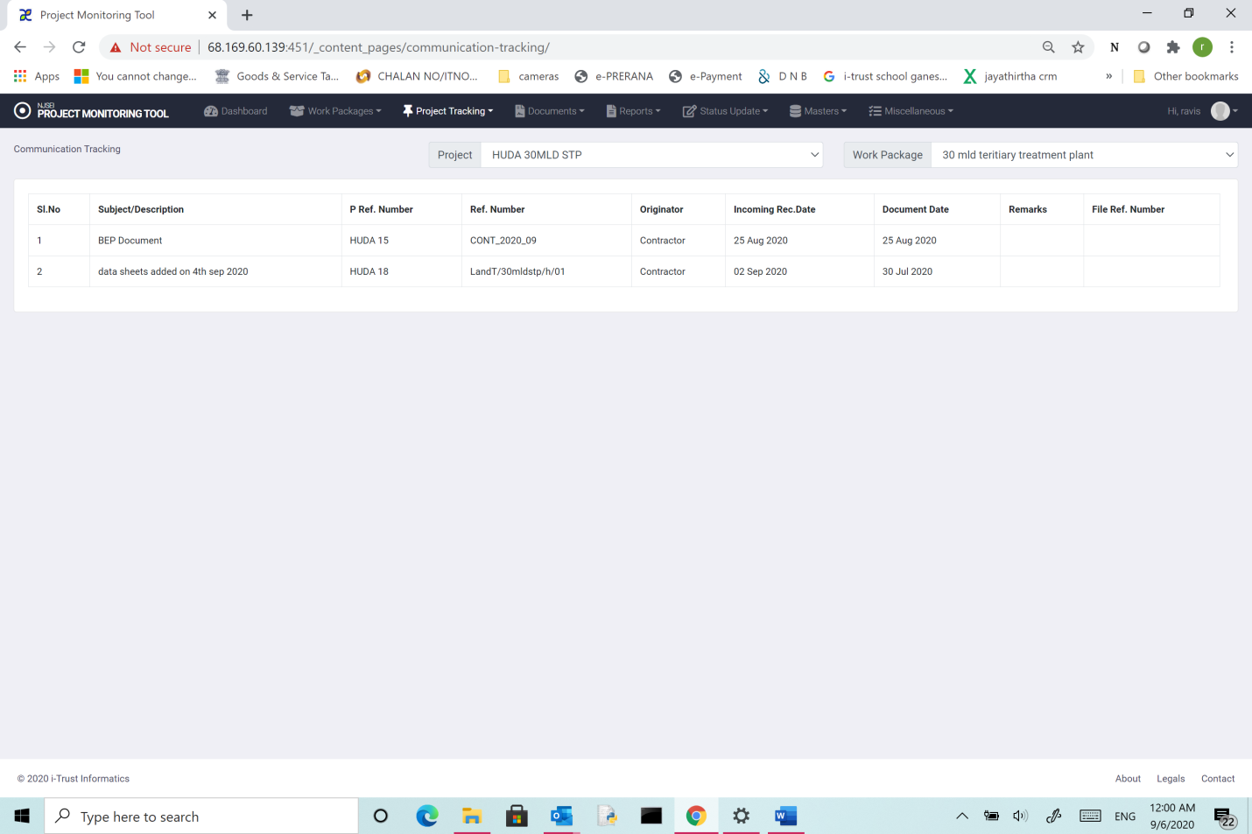

Select the Project and work package from the drop down options show. Then for chosen work package the communication details listed are shown.

1. Subject description: Subject of communication.
2. P-ref number: Project reference number.
3. Originator: Originator of communication- (NJSE/Contracotr/Client).
4. Incoming date: Date when communication was received at NJSE.
5. Document date: Date of the document ( as in document ).
6. Remarks: Any remarks when the communication was uploaded and
7. File ref no: NJSE file reference number.